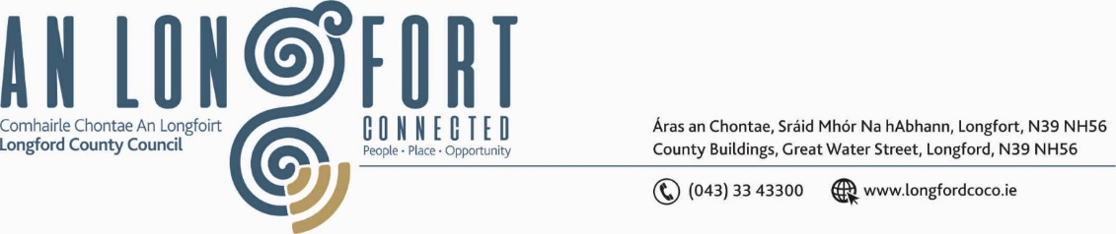

***BALLYMAHON MUNICIPAL DISTRICT***

***Please note meeting will be held via Microsoft Teams.***

**20th May 2021.**

**To: Each Member of Ballymahon Municipal District.**

**Dear Member,**

You are requested to attend a Meeting of Ballymahon Municipal District to be held

**via Microsoft Teams** on **Thursday, 27th May 2021 at 4pm.** to transact business, as set out on the Agenda hereunder.

**Yours sincerely**,

_______________

**Ann Marie Mc Keon,**

**Meetings Administrator.**

**AGENDA**

Prayer before meeting.

1. Confirmation of Minutes of Ballymahon Municipal District  **-**

1. Meeting held on the 25th March 2021 – copy enclosed.
2. Committee Meeting held on the 25th March 2021 – copy enclosed.

**2.** Matters arising from Minutes.

**3.** Declaration of Interest by Members.

**4.** Management Report - enclosed.

**5.** Consideration of applications for funding under the 2021 Community Grant Support

Scheme - list enclosed.

**6**. CCTV – Edgeworthstown - Presentation by Daniel Lynch.

**7. Notices of Motions, submitted by Councillors, as listed hereunder –**

**Councillor Mick Cahill**

I call on Longford County Council to provide suitable safe access to the National school in Killashee from the N63 as the situation at the moment is not adequate for the needs of the pupils in the interests of road safety.

**Councillor Paul Ross**

1. That Longford County Council start the process to enact bye laws in The Green public park, Edgeworthstown to regulate and control the use of the park.
2. That a review of the speed limit and road safety measures be carried out at the Lissaniskey, Castlecore, Shrule link road from the R392 to the N55 in Ballymahon as this road is now being effectively used as a bypass of Ballymahon town and is not fit for the volume or speed of the traffic using it.
3. “I call on Longford County Council to assist in setting up a Family Resource /Youth Services centre in Edgeworthstown”

**Councillor Pat O’Toole**

1. I call on Longford County Council to carry out an assessment of Leo Casey Terrace Ballymahon (14 houses) for a deep retrofit under the Just Transition Programme.
2. I call on Longford County Council in conjunction with Waterways Ireland and local landowners to carry out a feasibility study on the provision of Bridle Pathways from Longford Bridge Ballymahon to Abbeyshrule and or from Mosstown Kenagh to Lyneen Bridge.
3. Lack of parking spaces has become a serious issue at Newcastle Bridge with drivers regularly parking in close proximity to the junction of the Ballymulvey Road and the Newcastle Road when the car park is full I now call on Longford County Council to open discussions with local landowners or Coillte with a view to providing an additional car park at this scenic location which has seen a tenfold increase in visitors over the past 2 years.